Tax Invoice

**Invoice Number:** I2923HE000506248 **PacketID:** 9305970600 **Order Number:** 1215763-3715414-1249201 **Invoice Date:** 23 Sep 2022 **Nature of Transaction:**Intra-State **Order Date:** 23 Sep 2022

**Place of Supply:** KARNATAKA **Nature of Supply:** Goods

**Bill to / Ship to:**

# Sraban Kumar

Amaravati PG GENTS, 101D first floor

Brookfield Mall, Behind HP Petrol Bunk Kundalahalli Bengaluru - 560037 KA, India

**Customer Type:** Unregistered

**Bill From: Ship From:**

Health &Happiness Pvt Ltd

Survey Numbers 231, 232 and 233,, Soukya Road, Samethanahalli Village, Anugondanahalli Hobli, Hoskote Taluk ., BANGALORE, KARNATAKA-560067

**GSTIN Number:** 29AADCH8449J1Z0

Health &Happiness Pvt Ltd

Survey Numbers 231, 232 and 233,, Soukya Road, Samethanahalli Village, Anugondanahalli Hobli, Hoskote Taluk ., BANGALORE, KARNATAKA-560067

Qty Gross Amount

Discount Other Charges

Taxable Amount

CGST SGST/ UGST

IGST Cess Total Amount

**NIKEJCKT58596088 - Men Black Solid CLASSIC FZ FT Pure Cotton Formal Pant, Size: M**

**HSN: 61012000, 6.0% CGST, 6.0% SGST/UGST,**

1 Rs 3495.00 Rs 1698.00 Rs 0.00 Rs 1604.46 Rs 96.27 Rs 96.27 Rs 1797.00

**TOTAL Rs 3495.00 Rs 1698.00 Rs 0.00 Rs 1604.46 Rs 96.27 Rs 96.27 Rs 1797.00**

# Health &Happiness Pvt Ltd

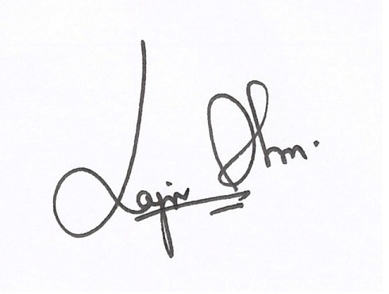

Authorized Signatory

**DECLARATION**

The goods sold as part of this shipment are intended for end-user consumption and are not for retail sale

**Reg Address:** Purchase made on

Health &Happiness Pvt Ltd,WZ199/2,Second Floor3,Madipur Village,Madipur,Delhi, , Delhi, Delhi-110063

If you have any questions, feel free to call customer care at **+91 80 6156 1999** or use **Contact Us** section in our App, or log on to [**www.myntra.com/**](http://www.myntra.com/) **contactus**